A Project Report on
Food Ordering Hub
Submitted in partial fulfillment of the requirement of project (BCE3009)
of
BE. Computer

Submitted to:
Purbanchal University
Biratnagar, Nepal
Submitted By
Kiran Silwal<730778>
Premal Kumar Shrestha <730784>
Shikshya Poudel<730790>

KANTIPUR CITY COLLEGE
Putalisadak, Kathmandu
11th December, 2023
A Project Report
On
Food Ordering Hub
Submitted in partial fulfillment of the requirement of project BCE3009
of
BE. Computer
Submitted to

Purbanchal University
Biratnagar, Nepal

Submitted By
Kiran Silwal<730778>
Premal Kumar Shrestha <730784>
Shikshya Poudel<730790>
Project Supervisor
Er. Prakash Gautam

KANTIPUR CITY COLLEGE
Putalisadak, Kathmandu
12th December, 2023
Table of Contents

Abstract I
Acknowledgement II
Preface III
Declaration IV
Supervisor approval V
Certificate form Department VI
1. Introduction 1
1.1 Overview 1
1.2 Problem statement 2
1.3 Objective 2
1.4 Features 3
1.5 Significance 3
1.6 Limitations and Scopes: 4
1.7 Organization of document 5
2. Literature Review 6
2.1 Point-of-Sale (POS) Systems: 6
2.2 Mobile Payment Apps: 7
2.3 Cloud-Based Billing Systems: 8
3. Methodology: 9
3.1 Software Development Life Cycle: 9
3.2 Technologies and Tools used 9
3.2.1 Specified Programming Language being used for the development 10
3.2.2 Integrated Development Environment 10
3.3 Assignment of roles and responsibilities 10
4. Gantt chart 11
5. Algorithm 12
6. Flowchart 15
7. System development and Implementation 17
• Programming platform 17
• Operating Environment 17
8. Testing and Debugging 19
9. Conclusion 22
10. References and Bibliography 22

List of figures

Figure 3.1.1 Software development cycle……………………………………….9

Figure 3.3.1 Assignment of team member………………………………………10

Figure 4.1 Gantt Chart…………………………………………………………...12

Figure 6.1. Flowchart………………………………………………………..15&16

Abstract

This project “Food Ordering Hub” is a simple console based application that proposes a “Bill calculation system” that uses file-based item storage system, price adjustment facility with consistent bill calculation to allow smooth operation of the hotel operations. This project makes it easy for employees of the hotel to enter customer requests after the order of the food is received so; the order process becomes more efficient. In addition to this, owners can easily update item along with its price according to the needs of the owner because of the mechanism of system to dynamically add or remove items. It has a user friendly interface and the facility of reorder and cancelation of order in case of certain errors in ordering process.
The primary focus of the project is the automated bill calculation system that helps in providing a total amount or simply bill by considering the item quantities along with the prices. This helps in speeding up the checkout process and helps in prevention of errors in bill calculation. This project further allows owner to save the sales report which can be accessed on monthly and weekly basis. So, this application can improves customer satisfaction overall. To conclude, this project's objective is to provide hotels with an efficient, affordable facility of bill calculation while controlling inventory and maintaining price flexibility through a proper system to update the menu.

Acknowledgement

First of all, we would like to express my heartfelt appreciation to everyone who played a direct and indirect role in the completion of this project titled “Food Ordering Hub”.
Without the immense support and belief from the people around us, this project would have been impossible. So, we would like to specially thank our project supervisor and mentor, Er.Prakash Gautam, whose crucial advice, immense support, and insightful as well as technical feedbacks played a huge role during the development process. His knowledge and suggestions has been invaluable in developing the project.
We are really grateful towards our Institution “Kantipur City College” for providing us necessary resources, supervisors for completion of this project. In spite of various obstacles and challenges faced during the development process, we would like to express our gratitude toward our peers, seniors and teachers for their heartfelt assistance and guidance.
Last but not least, we extend my appreciation to our family and friends for their unwavering support and encouragement throughout the completion phase of the project .Special appreciation goes to the hardworking team members who worked on various elements of the project. Their combined efforts and unwavering dedication led to the success of this project

Preface

This project "Food Ordering Hub" is a project that unites computer science concepts with the particular requirements of hotel businesses in this hospitality focused on bill calculation and hospitality sector. This particular project offers file-based food item storage, allowing quick update to item prices and details. Because of the system's user-friendly design, employees can easily monitor inventories and produce correct bills. Among the noteworthy features are automated reorder facility, which ensure timely bill calculation for smooth operations. This will help in terms of efficiency, mistake reduction, and customer satisfaction. As we celebrate this achievement, we look forward to seeing how our system continues to transform invoicing procedures, improve hotel operations, and establish new benchmarks in the hospitality businesses.

Declaration

We declare that this project titled “Food Ordering hub” submitted in partial fulfillment of the BE Computer 3rd semester is a record of the original work carried out by us under the supervision of Er. Prakash Gautam and has not formed the basis for the award of any diploma, in this or any other Institution or University. In keeping with the ethical practice in reporting information, due to acknowledgements have been made where the findings of others have been cited.
Kiran Silwal<730778>
Premal Kumar Shrestha<730784>
Shikshya Poudel<730790>

Date: 2023/12/12

Supervisor approval

This is to certify that the major project entitled Food Ordering Hub undertaken and demonstrated by Premal K.Shrestha<730784>, Kiran Silwal<730778>, Shikshya Poudel<730790> has been successfully completed under my supervision as a partial fulfillment of the requirements for the degree of BE. Computer, Third Semester under Purbanchal University. I , henceforth, approve this project to be awarded the certificate by the concerned authority.

During supervision, I found students hardworking, skilled and ready to undertake any professional work related to this field in future.

……………………..
Er. Prakash Gautam
Project Supervisor
Lecturer, Computer Department

…………………….
Date: 2023/12/12

Certificate form Department

Following the Supervisor’s Approval and Examiners’ Acceptance, the project entitled “Food Ordering Hub” submitted by Kiran Silwal<730778>, Premal Kumar Shrestha<730784>, Shikshya Poudel<730790> and as a partial fulfillment of the requirements for the degree of BE. Computer, Third Semester under Purbanchal University, has been officially awarded by this certificate.

I wish the students all the best for their future endeavors.

………………………………

Er.Subash Rajbanshi
HoD ,Department of Computer Engineering
Date: 2023/12/12

1. Introduction
In the present competitive world of hospitality and hotel businesses, efficient ordering and billing system plays a crucial role. “Food Ordering Hub”, is a simple yet efficient and provident solution focusing to facilitate the hotel operations especially with provision of order management, bill calculation and report keeping system. The project focuses on order processing with a file-based storage system and includes user-friendly interfaces that allow the employees and owners to easily input the order placed by the customer. A dynamic update mechanism for both the price and item and a faster ordering process are some of our project’s most important features that enable the business owner to be prepared or competition and react according to the changing market. Through the automated bill calculation system, the errors, delay of the checkout process is thoroughly reduced. The saving of sales report adds to the consistency of our system. So, our project focuses on changing the process of storage of food items along with the bill calculation to ensure efficient and quick customer service

1.1 Overview

The “Food Ordering Hub” is a simple yet practical project that prioritizes on bill calculation and file inventory system. An efficient file-based item storage technique on the basis of designated food items where owner can both save and update data along with the sales report has been emphasized by our project. Due to its user friendly interface, the records from customers are easily recorded. A dynamic pricing update method for real-time revisions is ensured by the system and a facility of reorder, if there has been irrelevant error during ordering process. The most notable feature of our project is the automated bill calculation system, which makes the overall experience for customers satisfactory by solving human error problems and speeding up the checkout operation. This project focuses on solving the problem of inventory management, adjustment of item, bill calculation while providing a easy, efficient approach.

1.2 Problem statement

After going through research and visiting some of the hotel businesses we can across various problems faced by the businesses. There is actually absence of order processing, inventory management in the present hotel businesses at most locations. There is manual processing of these operations which frequently results in mistakes, reducing pricing and invoicing accuracy. This leads to lack of customer service as well as degraded customer satisfaction. Most hotels are unable to update or adjust according to the changing market and the price update facility is time consuming and hectic. Furthermore, there is lack of cost-effective options for businesses with low resources, limiting their capacity to harness sophisticated technology for operational development. There is lack of user friendly interface for these kinds of system as reorder as well as tem update facility is hectic and hard to understand for many people. This proposal proposes an automated bill calculation system to overcome these challenges.

1.3 Objective

The major objectives of the projects are given below:
- To create an order management system for order processing and bill calculation.

- To help in management of sales report.

1.4 Features

This project focuses on order management through proper file based storage inventory system for the business entities. Some of the major features of this project have been provided below:
- Automated Bill Calculation
- Dynamic item and price update
- Reorder system
- File based item storage
- Sales report
- Discount on the items

1.5 Significance

The "Food Ordering Hub," which includes a file-based item storage facility as well as a bill calculating system, adds to the specific challenges encountered by hotel companies. Its streamlined approach to order processing, inventory management, and pricing computation boosts productivity by decreasing human errors, resulting in more efficient transactions. The dynamic item and price updates system allows hotels to swiftly react and make adjustments in response to market realities. A reorder option makes handling recurring client requests easier, adding to a more efficient customer experience. As a low-cost option, the effort democratizes better technology for a wider range of organizations. This project's C++ implementation displays technological innovation by providing practical applications that aid in educational and professional progress in the disciplines. Ultimately this project aims to solve the problems of inventory management and billing calculation to increase the customer satisfaction.

1.6 Limitations and Scopes:

The scopes of this project have been mentioned below:
- There is emphasis on order management form processing of order to the automated bill calculation system which will ensure customer satisfaction and efficiency.
- Since, this project has been completed using C++, it is compatible and platform independent.
- The facility of reorder will prevent errors and complexity in bill calculation.
- The feature of dynamic item addition and price update will help owners adapt to the market according to the changes seen in market in real time.
- The practical implications of this project are high and can be implemented on hospitality based industries available in the market.
Although, this project has practical application for various industries, there are some limitations of the project which has been mentioned below:
- There might be problem for initial setup as the user might be unfamiliar to the system and the setup process requires careful monitoring.
- There might be problem of stability for large organizations that requires more data to be stored.
- This application can only be used by literate employees with the basic knowledge and understanding of the system.

1.7 Organization of document

The content is structured in such a way that it gives a comprehensive understanding of the Automated Hotel Bill Calculation System project. The introduction establishes the tone by describing industry challenges and clarifying the issue statement. A thorough review of the literature explores current systems and research, giving background for the endeavor. The methodology section goes into detail on the C++ implementation, emphasizing the file-based storage system, dynamic pricing, and automatic invoicing mechanism. Through the use of visual aids, the system design clarifies the architectural and operational elements. The implementation section contains C++ code samples as well as solutions to probable problems. The evaluation and findings include information on system performance, user feedback, and comparative research. The discussion assesses the findings, acknowledges limitations, and considers the implications for the hotel industry. The conclusion outlines major findings and makes recommendations.

2. Literature Review
The most significant road to hotel company success in the hospitality sector is the proper handling of invoicing operations. With the advancement of technology, unique Bill Calculation Systems have emerged, expediting financial processes and increasing customer satisfaction. This study of the literature delves into three important types of applications in this sector, digging into their functioning processes, benefits, and potential downsides. Some of the systems we encountered that are similar to our project have been mentioned below along with its working mechanism, pros and cons:
- Point of Sale (POS) systems
- Mobile Payment Apps
- Cloud Based Billing System

2.1 Point-of-Sale (POS) Systems:

In hotels, POS systems are commonly used for real-time bill calculation at various service points such as restaurants, bars, and spa facilities. These technologies communicate with the hotel's central database to update costs for services used by guests in real time. They frequently contain functionality like bill splitting, discounting, and managing different payment methods.
Pros:
Some feature of Point Of Sale system are:
- It helps to instantly update the guest's bill, ensuring accuracy and transparency.
- There is smooth integration with other hotel management modules for centralized control and reporting.
- It has higher operational efficiency due to proper order processing and bill calculation.

Cons:
Some lacking features of this system are:
- Initial Investment: Implementation costs, including hardware and software, can be significant.
- Staff Training: Proper training is crucial, and staff resistance to adopting new technology may pose challenges initially.

2.2 Mobile Payment Apps:

Overview:
With the introduction of mobile payment applications, hotels are quickly putting into place solutions that let guests connect their payment methods to their mobile devices. With the help of these apps, users can keep an eye on and pay their bills using their smartphones. Receipts can be viewed online and payments are handled securely.
Pros:
- There is convenience of settling bills from their mobile devices.
- There is paperless transaction
- It is swift and easily accessible.
Cons:
- The reliance on mobile networks may lead to some vulnerabilities.
- There is limited accessibility.

2.3 Cloud-Based Billing Systems:

Overview
With cloud-based billing solutions, all billing data is centralized in a safe online environment. They facilitate real-time cooperation and ease access from numerous hotel departments. This includes the price of lodging, additional services, and other incidentals.
Pros:
- It is accessible from any location with an internet connection.
- It has bigger scalability.
- There is feature of automatic update from the server.
Cons:
- It is highly dependent on Internet.
- There is concern of data security.

3. Methodology:

3.1 Software Development Life Cycle:
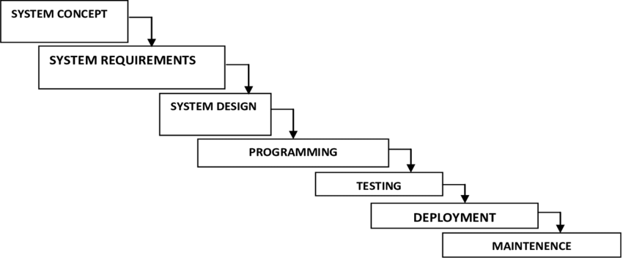
Figure 3.1.1. Software Development Life Cycle

3.2 Technologies and Tools used

Various tools and technologies were used for the completion of our project.
The most important tool used was the programming language C++, whose features played the most important role for providing us efficient coding environment. Dev C++ which is a free full-featured integrated development environment (IDE) was used for the coding process. Search Engines such as Google was used for gathering further information along with the help of website draw.io for creation of flowchart.

3.2.1 Specified Programming Language being used for the development

C++ is a flexible and strong programming language that is well-known for its efficiency and performance. It provides developers with flexibility by supporting both procedural and object-oriented programming paradigms. Strong typing, low-level memory management, and a large standard library are among its important features. Because C++ allows for high-performance applications, it is a popular choice for system-level programming, game development, and resource-intensive jobs. The language is still evolving, incorporating current features like as smart pointers and lambda expressions. Its vast aplication across industries demonstrates its continuing relevance, cementing C++ as a cornerstone in the field of software development.

3.2.2 Integrated Development Environment
Dev-C++ is an integrated development environment (IDE) for the C and C++ programming languages. The MinGW compiler equipped version is suitable for various stages of software development due to the integrated debugger, syntax highlighting, code completion, and an easy interface. Dev-C++ includes a full environment for organizing, editing, and debugging code, as well as project management tools, template editors, and resource editors. Although no updates have been made in a long time, its open-source nature invites community collaboration and customizing. Despite its inadequacies in contrast to more contemporary IDEs, Dev-C++ remains an excellent alternative, particularly for newbies and those searching for a basic, lightweight IDE for Windows C and C++ programming.

3.3 Assignment of roles and responsibilities

Member Name | Roles and Responsibilities
Kiran Silwal | Documentation, Code, Analysis
Premal Kumar Shrestha | Documentation, Code, Analysis
Shikshya Poudel | Documentation, Code, Analysis

Fg.3.3.1. Assignment of team members

4. Gantt chart

The gantt chart for this project has been provided below:
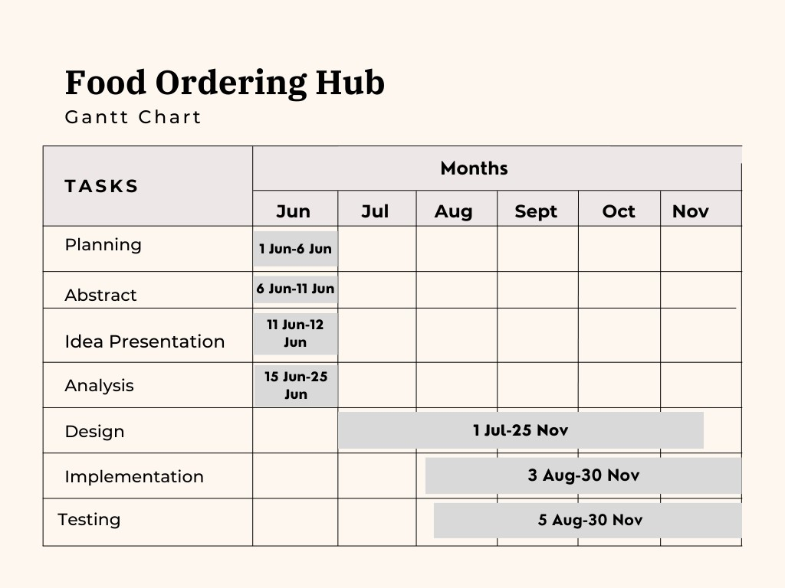

Figure 6.1. Gantt chart

5. Algorithm
The algorithm for the given project has been given below:
Step 1: Start
Step 2: Ask the user for name, password
  - If correct, Goto step 3
  - Else, Display Login Error, Goto Step 2
Step 3: Display and choose from the following options,
3.1 Order
3.2 Update
3.3 Sales Report
3.4 Exit

Step 4: Choose from the above choices.
Case 1 : if Choice is Order,
      - Display the item with prices
      - Display Id= 01 for returning back to the initial menu
Step 5: Choos the item from the given subtopics with the given ID of food item,
- Breakfast
- Lunch
- Dinner
- Drinks
- Display
5.1 Ask the user for Food Id
5.3 If the Id=01, Goto step 2
5.4 If Food Id is incorrect, Display, Invalid Id, Goto step 4
5.5 Ask user the quantity of food they want to order
5.2 If Food Id is correct, Goto step 6
Step 6: If the user puts the same Food ID twice, ask the user:
6.1 If the item is to be reordered or changed, Display and choose:
i. Add item
ii. Cancel order and reorder
6.1.1. If choice is add item, ask user for the item to be added and goto step 5
6.1.2 Else, Directly goto step 5
( Ask user for the discount amount)
Step 7: If ID=0, display bill with the items and the prices. And discount amount.
Step 8: Save the bill to the sales report.
Step 9: If the choice form step 3 is update,
Display:
- Add item
- Edit item
- Delete item
- Back

Case 1: If choice is add item, Goto step 10
- Ask the user name for new food item.
- Ask the user for new Food Id
Case 2: If the choice is edit item, Goto step 10
- Enter the Food ID to be updated
- Enter the item price or item to be updated
Case 3: If the choice is delete item, Goto step 10
- Enter the Food ID to be deleted
Case 4: If choice is back, Goto step 3
Step 10: Display the necessary food items with categories:
- Breakfast
- Lunch
- Dinner
- Exit
Step 11: If the choice is Sales report, Display:
- View all records
- Specific day records
- Monthly record
Case 1: If the choice is view all records, Goto step 12
Case 2: If choice is specific day:
Ask user to enter the year, month and day, Goto step 12
Case 3: if choice is monthly,
Ask user for the year and the month, Goto Step 12
Step 12: Display the sales report on the basis of given data by user.
Step 13: If choice from step 3 is exit, Goto step 14
Step 14: Exit

6. Flowchart
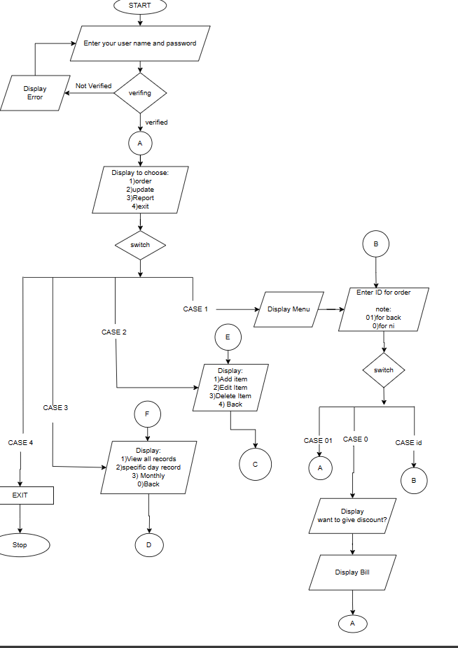

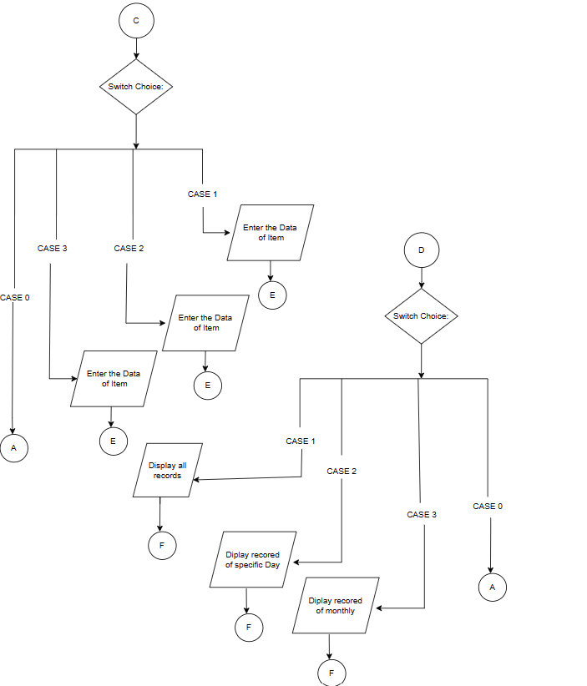

Figure 6.1 Flowchart

7. System development and Implementation

The development process took was complemented through various steps; idea generation for the order management, concept development on how the system will function when the project has been completed. The analysis and design process was completed after thorough research. Now, moving to the implementation part, C++ language was used as the programming language and VS Code was used as the programming platform.
- Programming platform
The coding platform that was used for this project was Visual Studio Code or simply VS Code. The reason we choose this software was because of the need to use C++ language for our project. It is open source and easily accessible for the users. Visual Studio Code's heart is a lightning-fast source code editor that is ideal for day-to-day use. With syntax highlighting, bracket-matching, auto-indentation, box-selection, snippets, and other features, VS Code allows you to be productive in seconds. We can transverse code with ease thanks to intuitive keyboard shortcuts, simple modification, and community-contributed keyboard shortcut mappings. It can be further be used for web development because of its in-built support for Node.js. It supports Windows, Linux and macOS too which makes it easy to access and use.

- Operating Environment
The necessary system, hardware, and software components that was used for this project has been mentioned below.
The project was completed using Windows, as its operating system.
The hardware which is used for the development of this project is
- Hardware 1:
Device name: Dell3567Win107Gen153000
Processor: Intel(R) Core(TM) i3-6006U CPU @ 2.00GHz 2.00 GHz
System type: 64-bit operating system, x64-based processor

- Hardware 2:
Device name: Dell Inspiron N4110
Processor: Intel(R) Core(TM) i5-2410MCPU @ 2.30GHz 2.40 GHz
System type: 64-bit operating system, x64-based processor

- Hardware 3:
Device name: Dell DESKTOP-UQD1S6K
Processor: 11th Gen Intel(R) Core(TM) i5-1135G7 @ 2.40GHz 2.42 GHz

System type: 64-bit operating system, x64-based processor

8. Testing and Debugging
The testing and debugging of the program for the project was done using Visual Code Studio. The testing process was completed by checking the input data provided by the user when the system is operating. During the testing phases various problems were found such as the file was not being found, the update function was not being executed properly and working on the files felt very hard. So, to solve these problems debugging was done. Debugging of these problems was time consuming but, it helped us find the necessary solutions through various Youtube videos, Google and the guidance of our supervisor. Here is the result of the testing process.

Test case: Login
S.  No. | Test case and description | Test case data | Expected result | Actual result | Status
1. | Login with valid username and password | Username: valid  Password: valid | User is logged in successfully | User is logged in successfully | Success
2. | Login with invalid username and password | Username: invalid  Password: invalid | User gets ‘Authentication Error’ | User gets ‘Authentication Error’ | Failed

Test case: Order
S. No. | Test case and description | Test case data | Expected result | Actual result | Status
1. | User enters the food id | Enter the Food Id: Valid | Food ID identified | Food id identified | Success
2. | User enters the quantity of food | Enter quantity of food item selected: Valid | Quantity is received | Quantity is received | Success
3. | User enters wrong ID | Enter the food ID: Invalid | User gets ‘Invalid Id’ | User gets ‘Invalid Id’ | Failed
4. | User enters the discount | Enter the amount of discount: valid | Discount amount is registered | Discount amount is registered | Success

5. | User enters ID for bill | Enter the valid id :valid | Bill is displayed | Bill is displayed | Success

Test case: Update item
S. No. | Test case and description | Test case data | Expected result | Actual result | Status
1. | User enters a choice | Enter the choice: valid | The user can then access the record and update them as well | The user can then access the record and update them as well | Success
2. | User enter Invalid choice | Enter the choice: invalid | Choice incorrect | Choice incorrect | Failed
3. | User adds the item | Enter the food Id and item to be added: valid | New item added | New item added | Success
4. | User edit the item and price of item | Enter the food id and new price: Valid | The item and the file is updated | The item and the file is updated | Success
5. | User edit the item and price of item | Enter the food id and new price: Invalid | Display ”Invalid Id” | Display ”Invalid Id” | Failed
6. | User delete the item and price of item | Enter the food id and new price: Valid | The item and the file is deleted | The item and the file is deleted | Success

Test case: Sales Report
S. No. | Test case and description | Test case data | Expected result | Actual result | Status
1. | User view all records | Enter the choice: valid | The user can view all report | The user can view all report | Success
2. | User view monthly record | Enter the Invalid date : invalid | Date format incorrect | Date format incorrect | Failed
3. | User view monthly record | Enter the valid date : valid | Date format incorrect and display the sales report | Date format incorrect and display the sales report | Success
4. | User view daily record | Enter the valid date : valid | Date format incorrect and display the sales report | Date format incorrect and display the sales report | Success

Test case: Exit
S. No. | Test case and description | Test case data | Expected result | Actual result | Status
1. | User chooses exit | Enter your choice:4 | User exits the program | User exits the program | Success

9. Conclusion
To sum up, this is a simple console based application developed using C++. This project focuses on solving the problems of the businesses related to the hospitality sector with the help of various features that includes instant bill calculation, price update, and file based item storage system for efficient inventory. The underlying problems of human error, lack of proper inventory and unavailability of the reorder system have all been solved in this system. This signifies the implications of our project in the real world. This system aims to help the businesses to achieve higher customer satisfaction through its ideal features and real world adaptability.

10. References and Bibliography

- Ogirima, Sanni Abubakar Omuya, Tolulope Reuben Awode, and Olajide Olusegun Adeosun. "Online computerized hotel management system." J. Comput. Biosci. Eng., ISSN (2014): 2348-7321.
- Singh, Smrita, et al. "Development of Hotel Management Information System." International Journal of Engineering Science 7793 (2016).
- Jagdale, Yogita, Neha Singh, and Mr Devidas Chikale. "Zigbee based hotel menu card and ordering system." International Journal of Technical Research and Applications 39 (2016): 12-15.

